IBM CLOUD ACCOUNT CREATION

Step 1:Search for “ibm.com/academic” in the browser

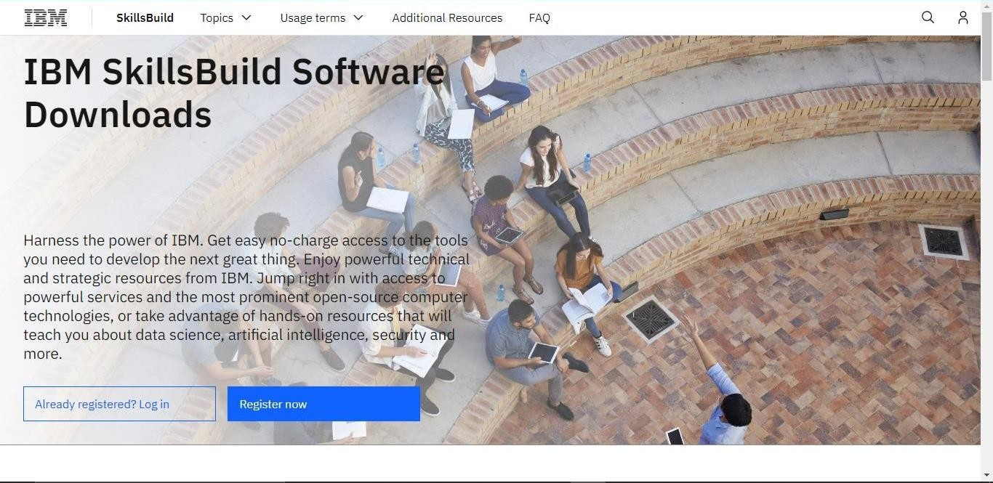

Step 2:Enter the mail issued by the academic institution and follow the procedure for entering the details which is provided as video link in your IBM profile.

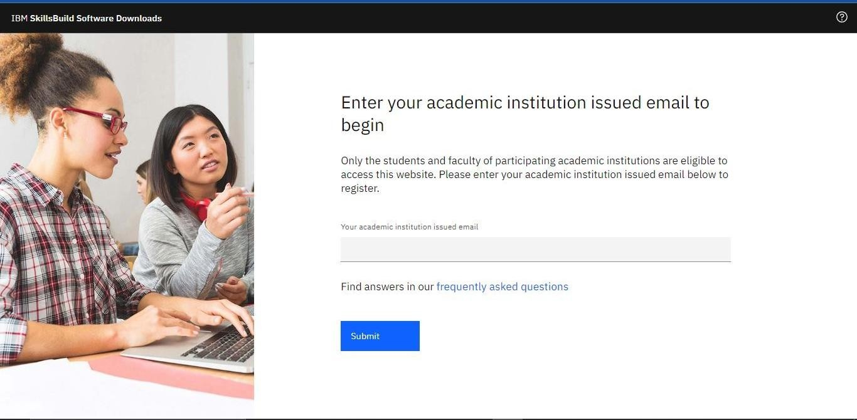

Step 3:After following the procedure that is given in reference video, your IBM cloud account wil created.

